**Suffolk Artlink Trustee recruitment**

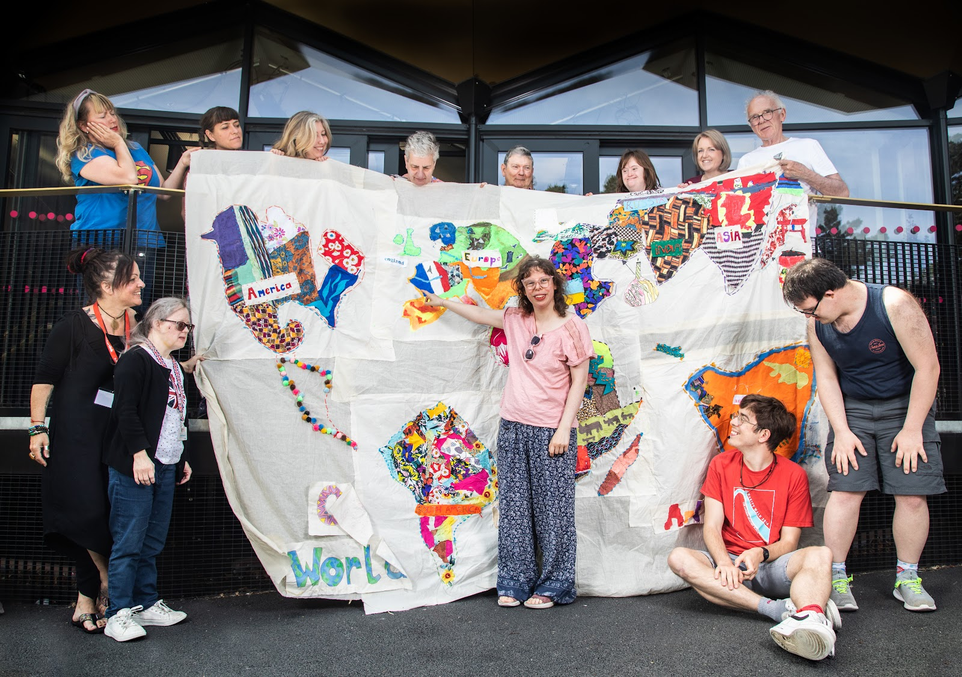

**About Suffolk Artlink**

We are a participatory arts charity. We develop and deliver inclusive arts programmes that support peoples’ health and wellbeing through quality artist-led activities in a rich variety of art forms.

For example, our project working with rural communities supported people to come together, building confidence and new skills post-COVID through foraging, preparing and sharing food together.

‘... When you are all sitting around the table you just automatically talk to people. We all did things together… I have gone to lots of groups, this one is friendly, we all messed in and cooked together. It is a ‘doing’ group…’

Suffolk Artlink is a registered charity and company limited by guarantee.

Charity No: 1110898 / Company No: 05354844.

**You can read about our work and its impact last year here:** <https://www.suffolkartlink.org.uk/about-us/annual-review-and-financials/>

**You can meet our team here:** <https://www.suffolkartlink.org.uk/about-us/>

**Trustee responsibilities and role description**

Our trustees play a vital role in making sure that Suffolk Artlink achieves its core purpose. They oversee the overall management and administration of the charity. They also ensure that we have a clear strategy and that our work and goals are in line with our vision.

Just as importantly, they support the staff acting as critical friends and lending their skills and expertise if and when required. Board members have a collective responsibility. This means that trustees always act as a group and not as individuals.

**Trustees:**

* **Support and provide advice** on Suffolk Artlink’s purpose, vision, goals and activities.
* **Approve operational strategies and policies and monitor and evaluate** their implementation.
* **Oversee Suffolk Artlink’s financial plans and budgets** and monitor and evaluate progress. Review and approve financial statements.
* **Ensure that key risks are identified, monitored and controlled** effectively.
* **Keep abreast of changes** in the environment within which Suffolk Artlink is operating- in the East of England and beyond.
* **Attend board meetings**, prepared to contribute to discussions. There are four Board meetings a year; subcommittees in finance, communications and fundraising; and workgroups as needed from time-to-time. Trustees may also contribute individually, mentoring a member of staff, or supporting a particular programme or functional area.
* **Use independent judgement**, acting legally and in good faith to promote and protect the interests of Suffolk Artlink and its wider community of staff, participants and partners.
* **Contribute to the broader promotion of Suffolk Artlink’s aims** and reputation by applying your skills, expertise, knowledge and contacts.

As we are a small charity, there are times when trustees are encouraged to be more actively involved beyond board meetings. We work creatively together at Suffolk Artlink, and we like to get creative and have fun together too! Trustees regularly attend our projects and events and contribute their ideas and time to making these a success.

**You can read more about the role of trustees on the Charity Commission’s website:** <https://www.gov.uk/guidance/charity-trustee-whats-involved>

**You can read about Suffolk Artlink’s current trustees here:**

<https://www.suffolkartlink.org.uk/about-us/>

**What we are looking for from our new Trustees**

We regularly review our board’s composition. In order to ensure that we have the people with the right skills and experience to support the delivery of our strategy, we are looking for the following skills, knowledge and experience (we do not expect to find all of these skills in one person!):

* **Business and commercial experience-** People with experience of growing a business and who are entrepreneurial.
* **Communications experience –** to help us build our relationship with our audience both online and in person.
* **Human resources experience** – to support staff development and management.
* **Creative** **experience**– are you an artist, maker or creative? You might be a professional or a hobbyist, naturally, we would welcome a creative voice around the table.
* **Sustainability/environmental impact**– we are committed to reducing our environmental impact and this is also increasingly important to our funders.

We want our Board to be representative of the communities we serve. We welcome applications from everyone including those who may not typically identify themselves with the arts sector or governance roles.

Those who identify as disabled, deaf or hard of hearing, visually impaired or neurodivergent are currently underrepresented on our Board of Trustees so we particularly encourage applications from those who identify as such. Applications from people from an ethnically diverse background are also actively encouraged.

If you can bring a new perspective we want to hear from YOU!

**The qualities we look for from all our trustees:**

* A commitment to the mission, aims and objectives of Suffolk Artlink
* Ability to meet the time requirement (more on that below)
* Integrity
* Good judgement
* An ability to think creatively
* A willingness to speak your mind and to respect others
* An understanding and acceptance of the responsibilities and liabilities of trusteeship
* Ability to be an effective member of the team.

**What you will gain from being a Trustee at Suffolk Artlink:**

* Make a significant difference to the lives, health and wellbeing of our beneficiaries and communities across the East of England; contribute to the professional development of our artists and to our influence upon the wider, national agenda around the arts and wellbeing.
* Use your existing skills, knowledge and networks to support Suffolk Artlink, while improving your own skills, knowledge and networks. Training and development provided as needed.
* Work alongside a committed and varied team of trustees who are all committed to maintain and grow Suffolk Artlink’s impact.
* Feel great by giving back!

**But don’t just take our word for it!**

‘In the 12 years that I have been fortunate to be part of this amazing organisation I have seen many changes. It has carefully and successfully evolved, adapted, improved and grown the much needed services it offers and its reputation has rightly grown accordingly. It has achieved this through the talent, creativity, professionalism and commitment of the people who work here.

The culture of care, consideration and mutual support is unrivalled in any organisation I have worked in and has been an inspiration to me.’

(Mike James, stood down during 2022).

**Time Commitment**

We usually meet for board meetings quarterly in Halesworth (currently weekdays, early evening 5pm to 6.30 pm.). Meetings are currently blended, in person and virtual.

Please note this is a voluntary position. Out of pocket and reasonable travel expenses are covered.

**The Board’s policy** is for trustees to serve a maximum of two terms of three years. Trustees undertaking the role of Chair, Vice Chair or Treasurer may serve a third term of three years.

**Application Process**

* If you have questions or would like to discuss your interest in becoming a trustee before applying, please contact trustee, Alice Whitney, 07878 448 870 / [Alice@creative-nation.co.uk](mailto:Alice@creative-nation.co.uk) or staff Alistair Winch, 01986 873955 / admin@suffolkartlink.org.uk
* Those interested in becoming a trustee will be invited to meet with trustees and the Co-Directors to learn more about the charity and the role.
* Appointment is subject to approval of the Board of Trustees
* Successful applicants will be invited to the Annual General Meeting on Monday, 31st July 2023, 4.30 pm

If you are unable to make any of these dates, please do not let that put you off applying. Just let us know and we will do our best to make alternative arrangements.

**How to apply**

To apply please email an expression of interest and CV to Alistair Winch, [admin@suffolkartlink.org.uk](mailto:admin@suffolkartlink.org.uk) by Monday, 17th April 2023. Or you can film your expression of interest if that is preferable.

Please read more about Suffolk Artlink on our website [www.suffolkartlink.org.uk](http://www.suffolkartlink.org.uk)

If you require this information in large print or audio file please call 01986 873 955.